Data Recovery Using TestDisk



Submitted By:

Name: Ganesh Balaji Bharakade
PRN:46423000368
Course: BCA in specialization with Cyber Security Department: Computer Science
Date of Submission: 20/09/2025

CERTIFICATE OF ORIGINALITY

I hereby certify that the project submitted under my name is ganesh bharkade the result of my independent efforts and creativity. I have diligently acknowledged all sources consulted and ensured the absence of any plagiarized content. Furthermore, I affirm that this project has not been previously submitted for publication elsewhere..

Name : Ganesh Bharkade
Allied Institution Tilak Maharashtr Vidyapeeth
Contact No: -9970271965

ACKNOWLEDGEMENT

I want to express my heartfelt thanks to Professor Anup Girdhar for their support and guidance during the research and writing of this project. Their expertise greatly improved the quality of my work.

I'm also grateful to my friends for their feedback and encouragement. Their input helped me refine my ideas.

Lastly, I want to thank my family for their unwavering support throughout this project. Their encouragement kept me motivated.

I'm thankful to everyone who contributed to the completion of this project.

Table of the Contents

1 | Abstract
2 | Introduction
3 | Problem Statement
4 | Objectives
5 | Research Methodology  - Process Flow Diagram  - Commands, Purpose, and Steps  - Screenshots
6 | Output / Findings
7 | Future Scope
8 | References
9 | Annexure: Certificate of Electronic Evidence

Abstract

Data recovery is a crucial aspect of cybersecurity and digital forensics. This project focuses on restoring accidentally deleted files using TestDisk, an open-source recovery tool. The implementation includes scanning the storage medium, recovering files, and verifying their integrity through hash values. The project highlights the importance of reliable recovery methods and emphasizes preventive measures such as regular backups to minimize future data loss.

Introduction

In the digital era, data is one of the most valuable assets for individuals and organizations. However, accidental deletion of files is a common problem that can cause significant disruption. Data recovery techniques are therefore essential to restore lost information without damaging existing data.
This project demonstrates the use of TestDisk, an open-source data recovery tool, to recover deleted files from a workstation. The process covers identification of deleted files, recovery steps, verification of data integrity, and preventive measures to avoid future data loss.

Problem Statement

A user has accidentally deleted critical files from their workstation. The task is to recover the deleted files securely, ensuring data integrity, and preventing damage to existing data.

Objective

Select an appropriate tool (TestDisk) compatible with the file system.
- Scan and recover deleted files without harming other data.
- Verify the integrity of recovered files.
Educate the user about backup and preventive measures

Research Methodology

- Process Flow Diagram

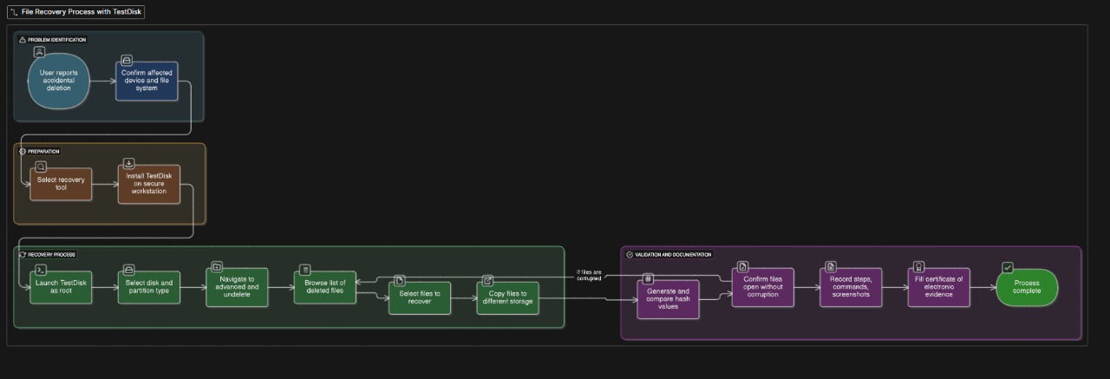
Linux Commands – Purpose & Steps to Implement

- sudo fdisk -l

Purpose:
Lists all disk partitions and details (size, type, mount points). Useful in disk management and digital forensics.

Steps to Implement:
- Open terminal.
- Run the command:
- sudo fdisk -l
- It will display all connected disks and partitions.

2. ls -la
Purpose:
Lists all files and directories (including hidden ones) with detailed permissions, size, and timestamps.
Steps to Implement:
- Navigate to the desired directory using:
- cd /path/to/directory
- Run the command:
- ls -la

3. stat <filename>
Purpose:
Displays detailed file metadata such as size, permissions, access, modify, and change times.
Steps to Implement:
stat file.txt

4. md5sum <filename>
Purpose:
Generates the MD5 hash of a file. Useful for file integrity verification.
Steps to Implement:
md5sum file.txt

5. sha1sum <filename>
Purpose:
Generates the SHA1 hash of a file. Stronger than MD5 for integrity checking.
Steps to Implement:
sha1sum file.txt

6. sha256sum <filename>
Purpose:
Generates the SHA256 hash of a file. Provides stronger verification compared to MD5 and SHA1.
Steps to Implement:
sha256sum file.txt

7. rm <filename>
Purpose:
Deletes a file or directory. Caution: Deletion is permanent unless recovery tools are used.
Steps to Implement:
rm file.txt # remove a file
rm -r foldername # remove a directory and its contents

8. cat <filename>
Purpose:
Displays the content of a file directly in the terminal.
Steps to Implement:
cat file.txt

9. sudo testdisk
Purpose:
A recovery tool used to restore lost partitions and recover deleted files.
Steps to Implement:
- Install TestDisk if not already available:
- sudo apt install testdisk -y
- Run TestDisk:
- sudo testdisk
- Follow the interactive menu to:
  - Select the disk
  - Analyze partitions
  - Search for lost data
  - Recover partitions or files

- Here Is Step By Step Images of how process will flow as shown in the Diagram
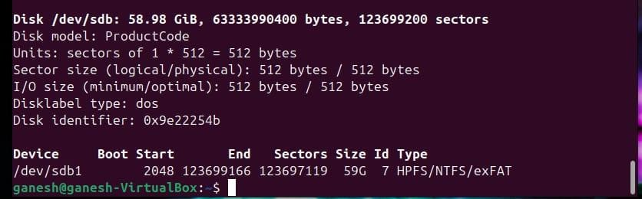
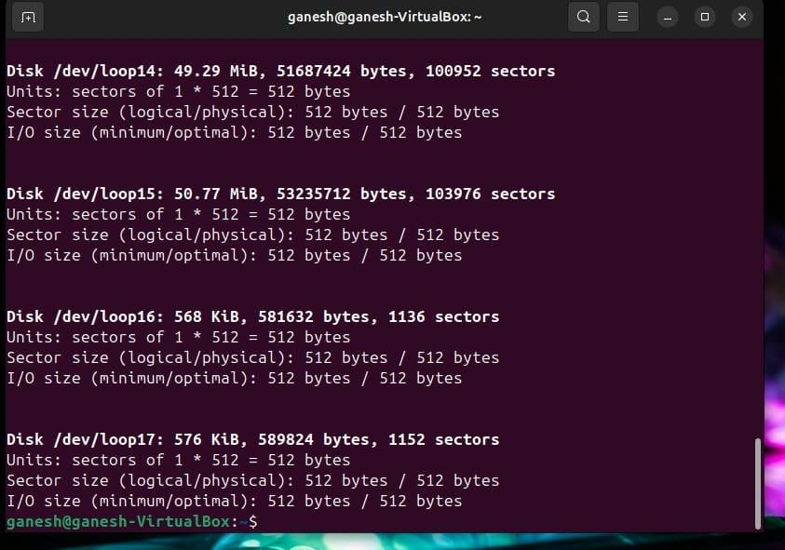
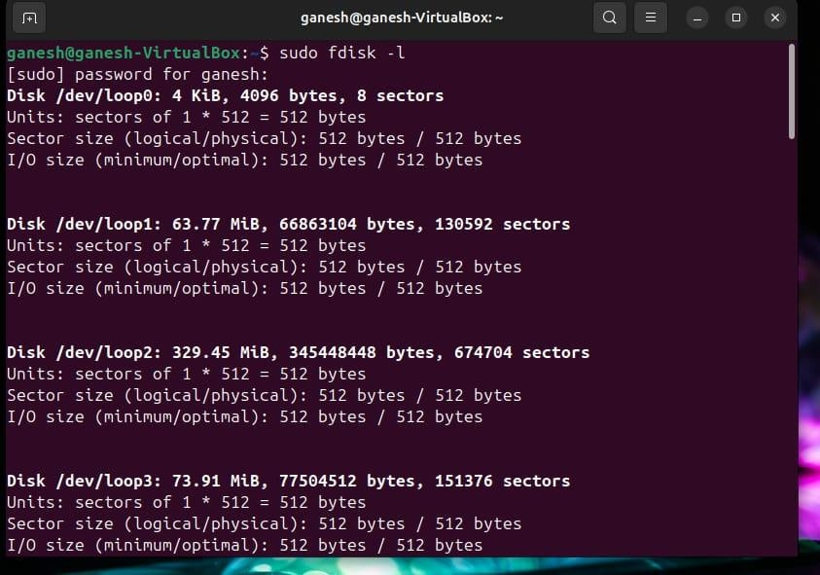

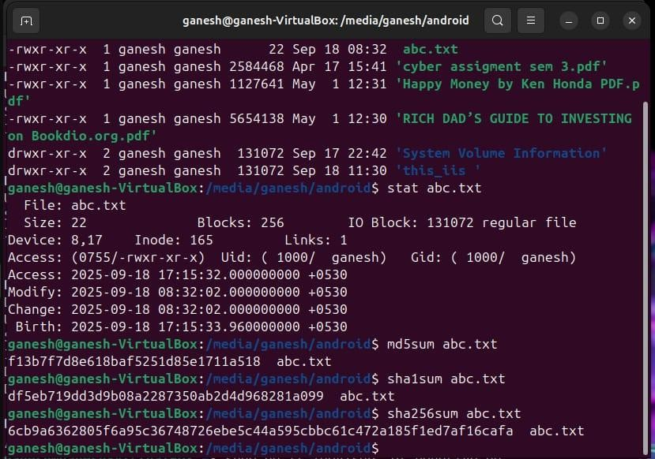
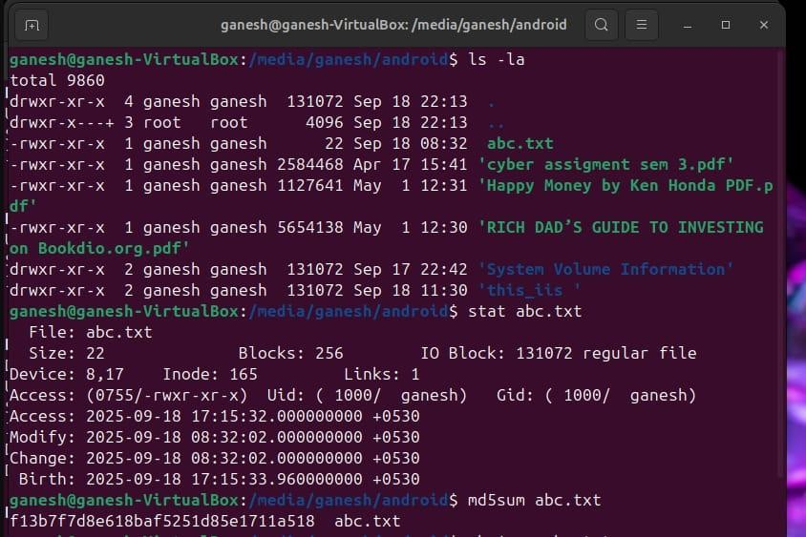

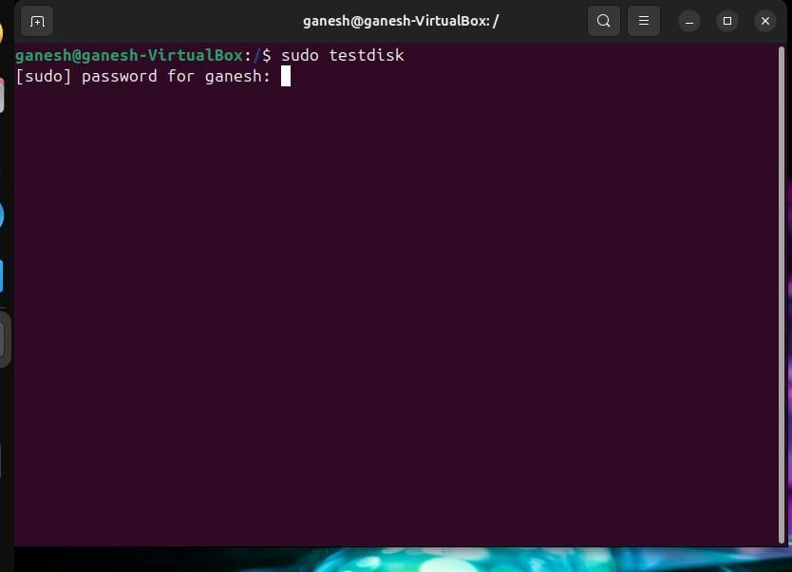
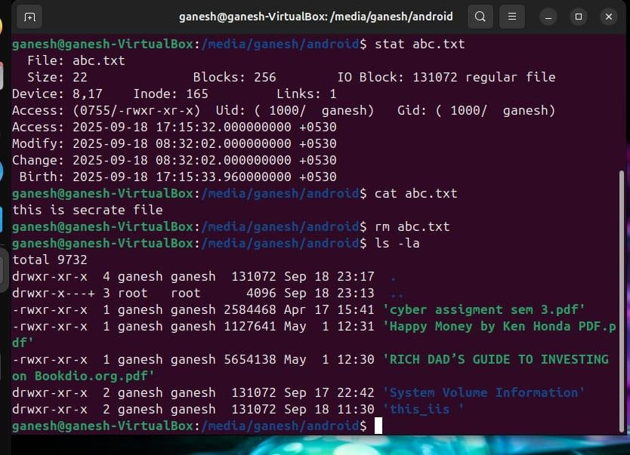
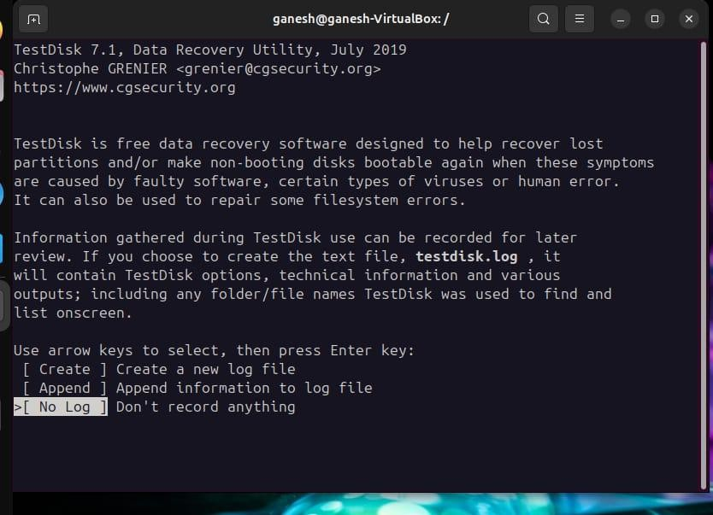
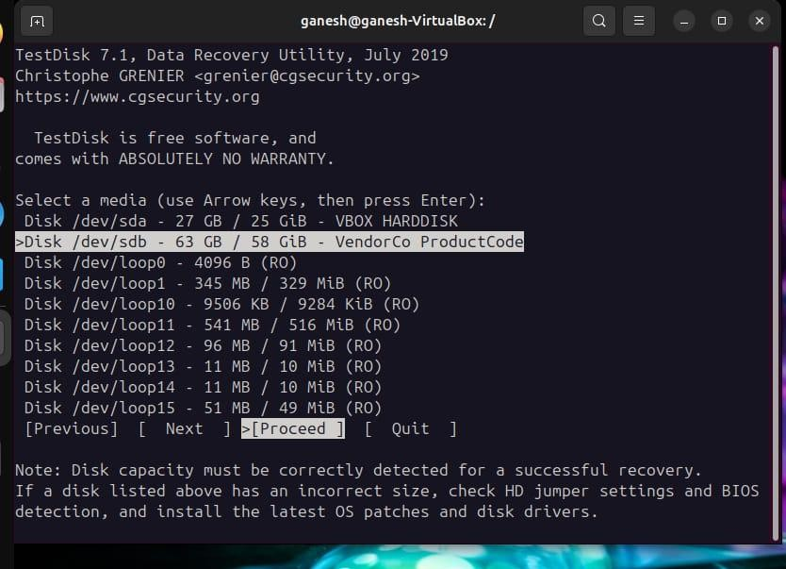

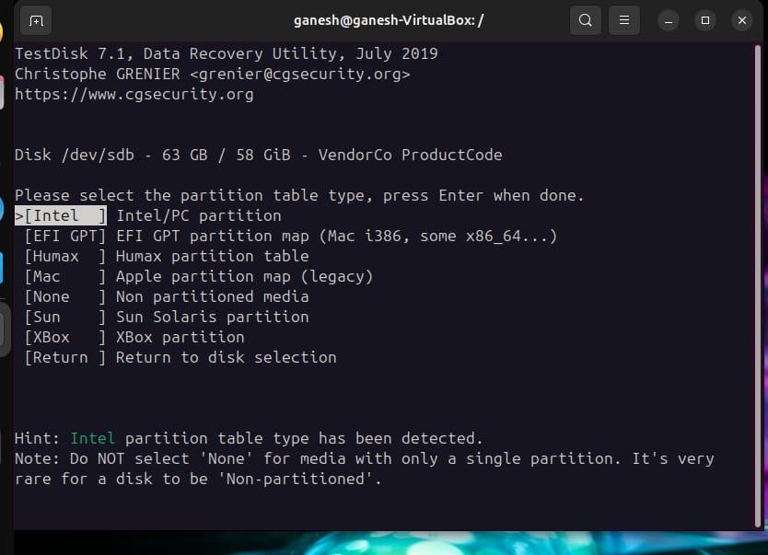
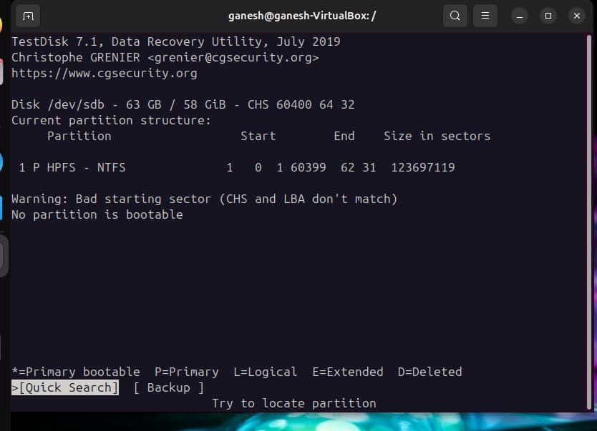

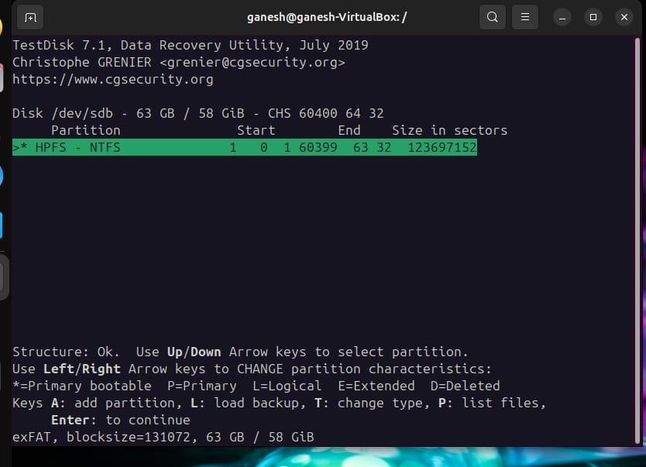
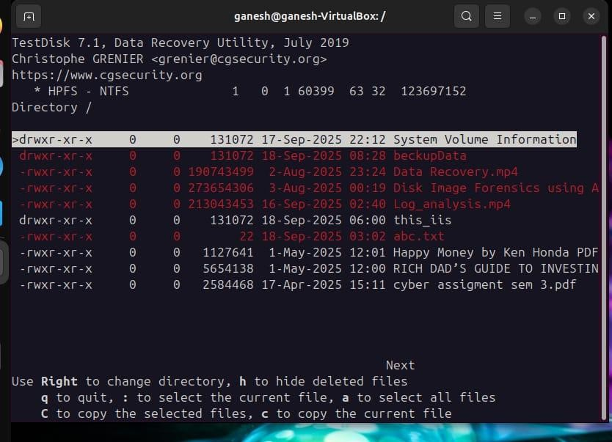

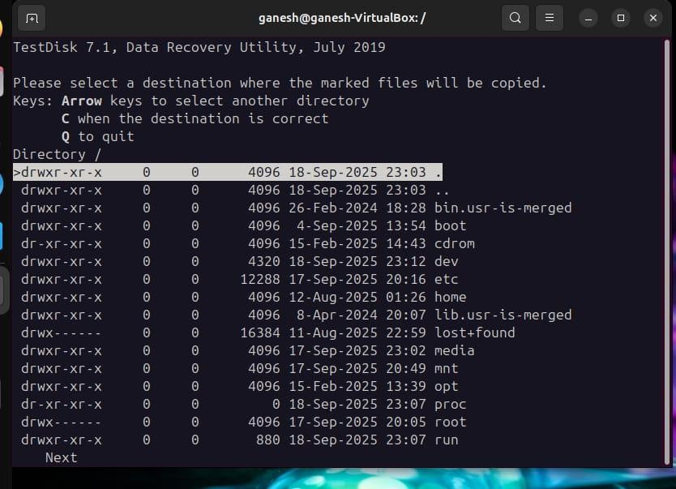
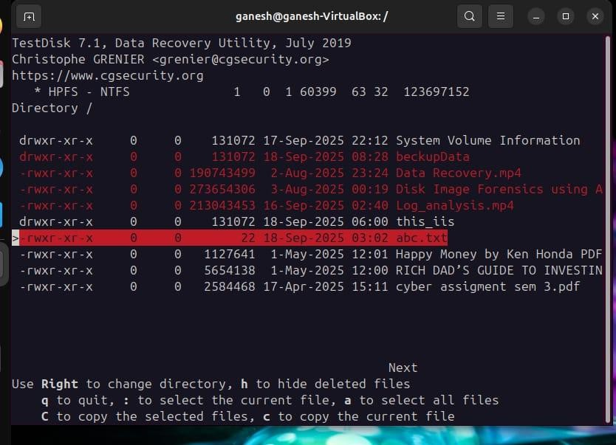

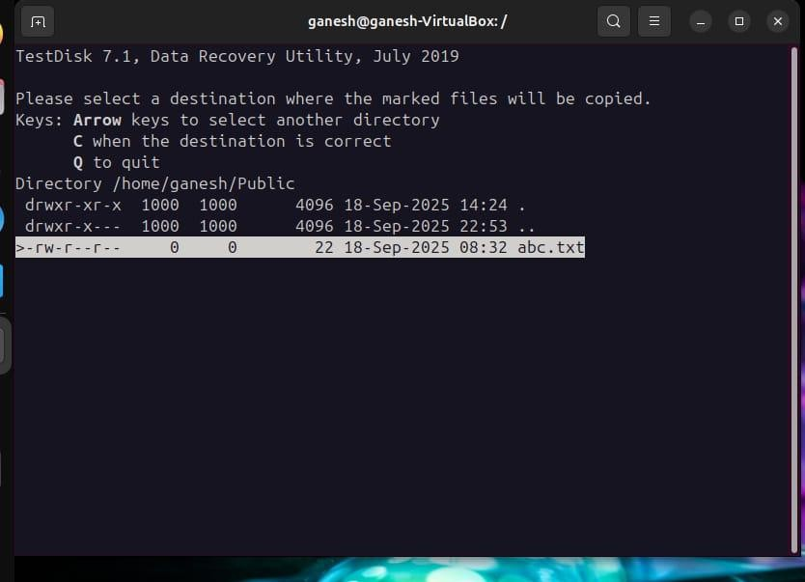
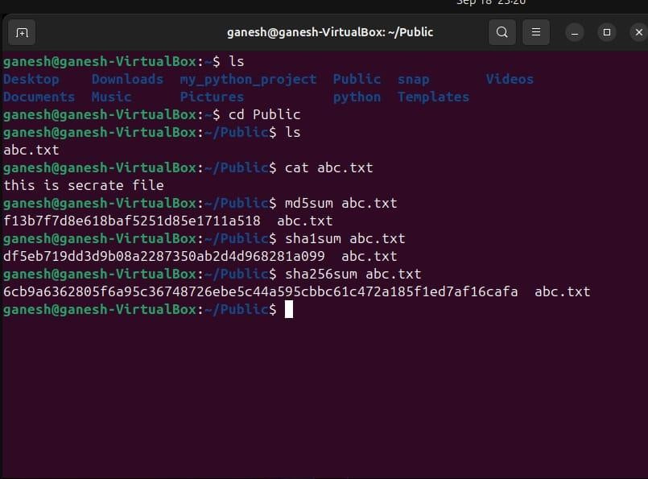

Output / Findings

- Deleted files were successfully recovered using TestDisk.
- Integrity was verified using SHA-256 hash values.
- No corruption or overwrite occurred during recovery.

Future Scope

- .Data recovery is not limited to restoring accidentally deleted files. As cybersecurity and digital forensics advance, the following future possibilities and improvements can be implemented:

- Automation of Recovery Processes
  - Develop scripts to automate disk imaging, recovery, and hash verification.
  - This will save time during large-scale incidents and ensure consistency in forensic investigations.

- Integration with Advanced Forensic Suites
  - Tools such as Autopsy and Sleuth Kit can be integrated with TestDisk to create a complete forensic workflow.
  - These platforms allow for timeline analysis, metadata extraction, and detailed reporting for legal evidence.

- AI/ML in Data Recovery

  - Artificial Intelligence and Machine Learning can be applied to identify fragmented or partially overwritten files.
  - Future tools may be able to reconstruct incomplete files using predictive analysis.
- Cloud and Virtual Environment Recovery
* As organizations move to cloud storage and virtualization, future recovery tools must handle recovery from cloud snapshots, virtual disks, and container environments .
* Integration with platforms like AWS, Azure, and Google Cloud will become essential.

- File System–Specific Modules

  - Current tools are generic. Future development may focus on file
  - system–specific recovery modules (e.g., NTFS, ext4, APFS, Btrfs) for more precise and faster recover

- Blockchain for Evidence Integrity

  - Blockchain technology can be used to store hash values and logs of recovered files.
  - This ensures tamper-proof and legally verifiable integrity for forensic evidence.

- Enhanced User Awareness & Training

  - Future cybersecurity programs should include data recovery simulations as part of training.

  - Awareness about backup policies, digital hygiene, and recovery readiness will minimize accidental data loss.

- Cross-Platform Support

- Improved compatibility with mobile devices, IoT storage, and encrypted drives is expected.
- Recovery from SSDs with TRIM enabled (currently very difficult) is another research area.

Conclusion

No fluff, straight to the point: the recovery worked the way it should when proper precautions were taken, but it’s not magic — success depends on how soon you acted and whether data has been overwritten. Below I’ll summarize what was done, what actually
matters technically, the legal/forensic bits, lessons learned, and exact next steps / commands you should keep in the report.

References

- TestDisk Official Documentation – https://www.cgsecurity.org/wiki/TestDisk

- Linux Manual Pages --help , man etc

- Bharatiya Sakshya Adhiniyam 2023 – Certificate Format

Annexure – Certificate of Electronic Evidence

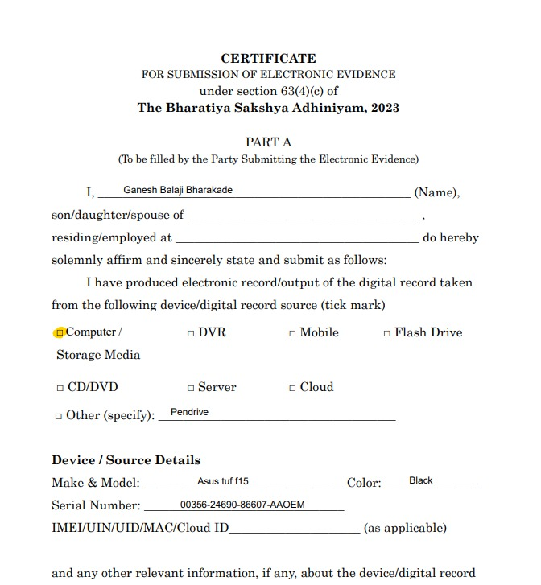

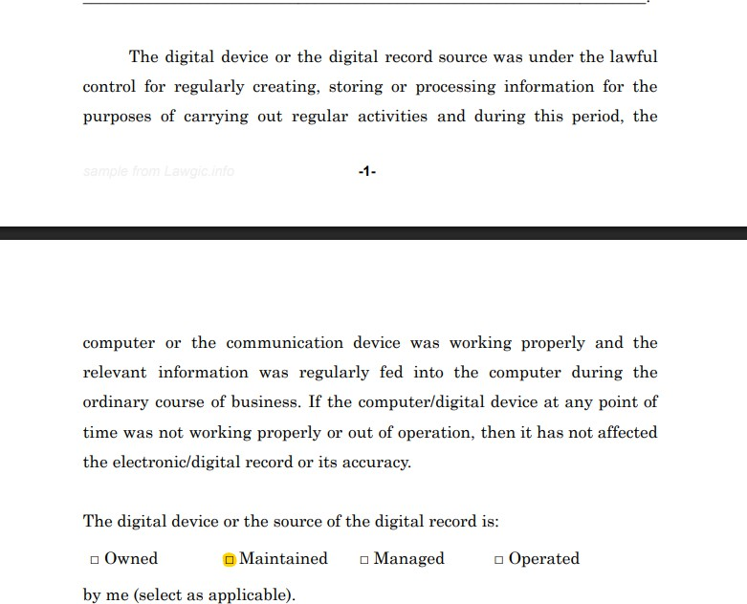

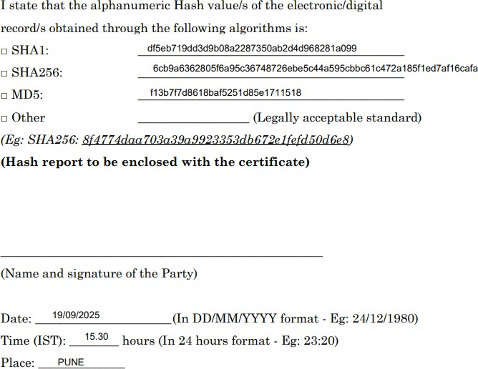



THANK YOU

